|  |  |  |  |  |
| --- | --- | --- | --- | --- |
| C:\Users\David\Dropbox\rossmoyne.png  **Reading Time**: An initial **2 minutes** to view **BOTH** sections | **MATHEMATICS METHODS : UNITS 3 & 4, 2022**  Test 2 – (10%) 3.2.4, 3.2.5, 3.2.8 to 3.2.22, 3.1.1 – 3.1.6, 3.1.9 | | |  |
| **Time Allowed**  30 minutes | | **First Name Surname  SOLUTIONS Mark 2** | **Marks**  29 marks | |

**Circle your Teacher’s Name:** Mrs Alvaro Mrs Bestall Mrs Fraser-Jones Mr Gibbon Mrs Greenaway Mr Koulianos Mr Luzuk Mrs Murray Mr Tanday

|  |  |
| --- | --- |
| **Assessment Conditions: *(N.B. Sufficient working out must be shown to gain full marks)***   |  | | --- | | * Calculators: Not Allowed * Formula Sheet: Provided * Notes: Not Allowed | |

**PART A – CALCULATOR FREE**

Question 1 [2, 2, 1 — 5 marks]

**Differentiate** the following. **(do not simplify your answer)**

(a) 

 ✓✓

Attempted use of power rule ✓

Correct answer ✓



(b) 

1st term ✓

2nd term ✓



* ✓

(c) 

 ✓

**Question 2 [2,1 - 3 marks]**

The motion of a particle, where  is the displacement of the particle in metres, and  is time in seconds, can be described by



1. Find the change in displacement during the first 3 seconds.

 ✓





 ✓

1. Interpret your result from (i)

Particle ends up 9 metres to the left of the starting position ✓ all three need to mentioned

**Question 3 [1 mark]**

A particle is moving along a straight line. The graph shows the acceleration of the particle.

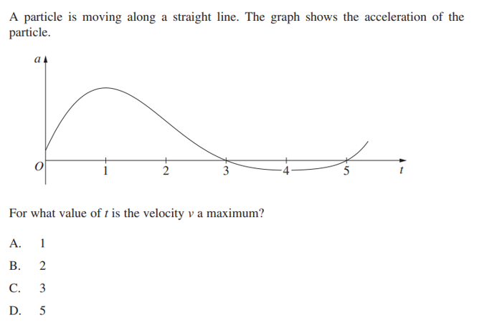

For what value of  is the velocity  a maximum

 ✓

**Question 4 [2, 2, 2 - 6 marks]**

1. If  determine the value of 



 ✓

 ✓

1. If  determine the value of 

 ✓



 ✓

1. Find  if 

 ✓

 ✓ 

**Question 5 [1, 1, 1, 1 - 4 marks]**

The graphs of  and  are shown below.

The graphs intersect on the  at points  and form the regions that are

labelled A, B, C and D

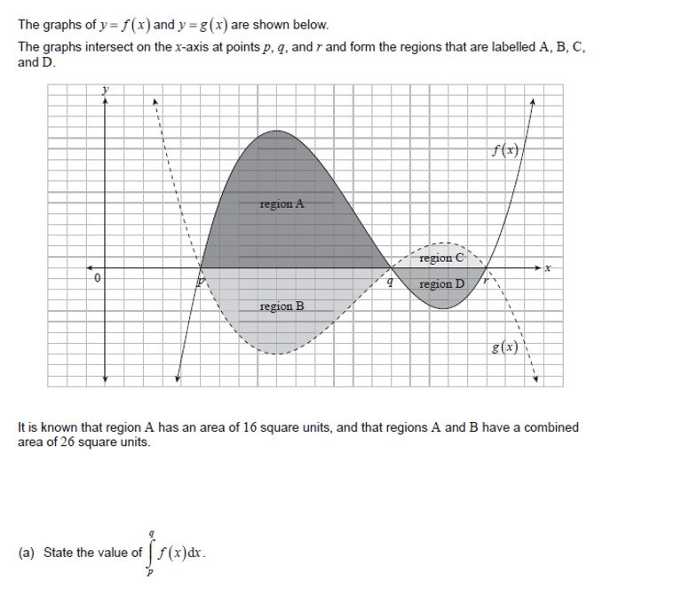

It is known that region A has an area of  square units, and that regions A and B have a

combined area of  square units.

 ✓

✓

1. State the value of 

 ✓

✓

1. State the value of 

It is also known that  and 

 ✓ 

1. Find the area of region C
2. Calculate the value of 

 ✓ 



Question 6 [2, 3 - 5 marks]

(a) Determine 

✓ ✓



(b) Hence determine 

 ✓

 ✓



 ✓

**Question 7 [2, 3 – 5 marks]**

1. Find 



 ✓

 ✓

1. If  and 

find 



✓



✓





 ✓

**End of section**

|  |  |  |  |  |
| --- | --- | --- | --- | --- |
| C:\Users\David\Dropbox\rossmoyne.png  **Reading Time**: An initial **2 minutes** to view **BOTH** sections | **MATHEMATICS METHODS : UNITS 3 & 4, 2022**  Test 2 – (10%) 3.2.4, 3.2.5, 3.2.8 to 3.2.22, 3.1.1 – 3.1.6, 3.1.9 | | |  |
| **Time Allowed**  20 minutes | | **First Name Surname** | **Marks**  23 marks | |

**Circle your Teacher’s Name:** Mrs Alvaro Mrs Bestall Mrs Fraser-Jones Mr Gibbon Mrs Greenaway Mr Koulianos Mr Luzuk Mrs Murray Mr Tanday

|  |  |
| --- | --- |
| **Assessment Conditions: *(N.B. Sufficient working out must be shown to gain full marks)***   |  | | --- | | * Calculators: Allowed * Formula Sheet: Provided * Notes: Not Allowed | |

**PART B – CALCULATOR ALLOWED**

Question 8 [3,2 — 5 marks]

The acceleration, *a*(*t*) m/s2, of a particle at time *t* seconds is given by

 where 

The velocity of the particle at *t* = 0 is 2 m/s.

(a) Find when the particle first changes direction, correct to four decimal places.

|  |  |
| --- | --- |
| ✓ no penalty if C missing  ✓  Solve  for stationary points  seconds ✓  (Accuracy Question)  Basically 2/3 if accurate answer , no units but C missing |  |

(b) Find the total distance that the particle travelled during the given time interval.

(Give your answer in metres, correct to 2 decimal places)

✓ ✓

Total distance =  metres

Question 9 [3 marks]

The region enclosed by  and  is shaded in the diagram

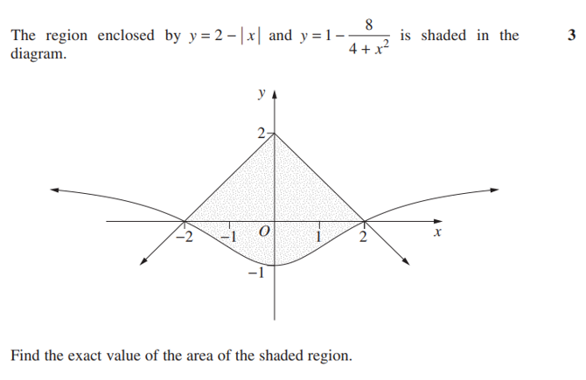

Find the **exact** value of the area of the shaded region

✓ ✓ ✓ ✓

Area of shaded region  or 

 square units ✓



Question 10 [1,2,2 - 5 marks]

Marie Curie, a French – Polish physicist and chemist, was the first woman to win a Nobel Prize, the first person and only woman to win twice, and the only person to win a Nobel Prize in two different sciences. In 1909, she succeeded in isolating 1 gram of pure radium. The decay function of radium (the amount remaining after  years) is approximately

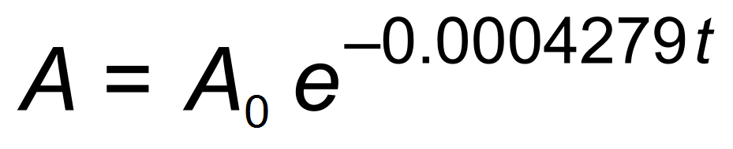 where *t* is time in years.

1. How much of the  of radium remains after 10 years.

|  |  |
| --- | --- |
| amount remaining =  ✓ |  |

1. Find the instantaneous decay rate after 10 years.

|  |  |
| --- | --- |
| ✓  grams/year ✓ | ✓    grams/year ✓ |

1. Determine the half-life of radium ?.Give your answer to the nearest year.

|  |
| --- |
| ✓  years  years ( nearest yr) ✓ |

Units Question for all three parts – if a unit is missing from any

of (a),(b) or (c) - deduct 1

Question 11 [3, 1, 2 - 6 marks]

Consider the graph of  , below, where

 

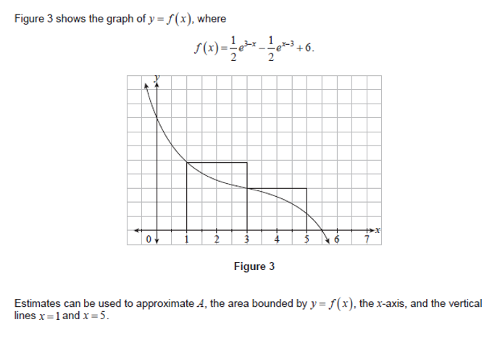

Estimates can be used to approximate A, the area bounded by  , the  , and

the vertical lines  and 

1. An upper estimate,  , of A can be calculated using the areas of two rectangles

of equal width, as shown in the diagram above.

Find the **exact** value of 

|  |
| --- |
| ✓  ✓  ✓ |

A lower estimate,  , of A can be calculated using the areas of two rectangles of equal width, S , as shown in the diagram below.

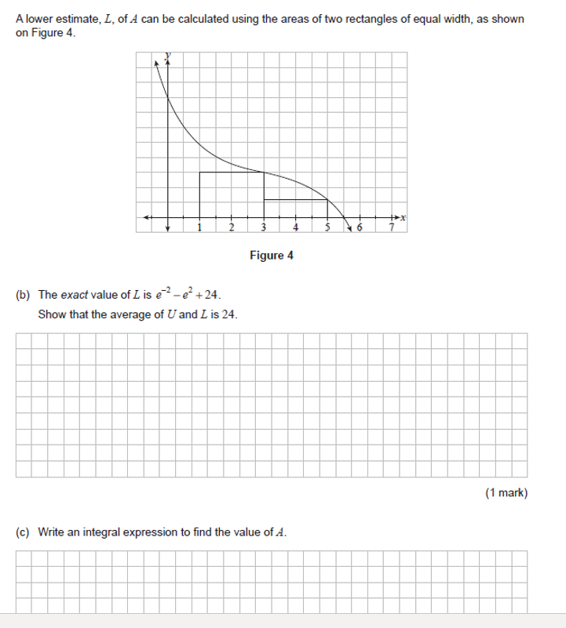

1. The **exact** value of  is given by 

Show that the average of  and  is 24

|  |
| --- |
| ✓ |

1. Calculate the **exact** value of A 

|  |
| --- |
| ✓    ✓ |

Question 12 [2, 2 - 4 marks]

The diagram shows two parabolas  and  , where 

The two parabolas intersect at the origin, and at A

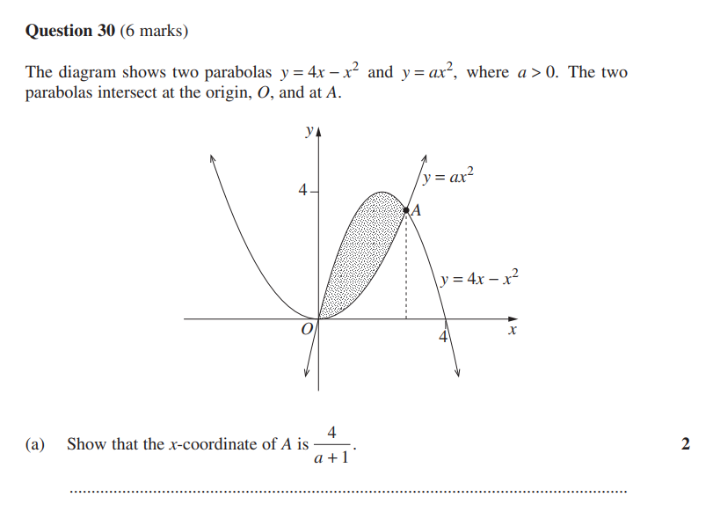

1. **Show** that the - coordinate of A is 

|  |  |
| --- | --- |
| ✓  ✓ | Or  ✓    ✓  discard x=0  is not mentioned as  a possible soln |

|  |
| --- |
| ✓    ✓ discard |

1. Find the exact value of  such that the shaded area is 

**Extra Page 1**